Welcome to
Trailblazers Nursery
at

We hope that this booklet will help with the process of settling children and parents into our nursery. We will be glad to answer any further questions not covered in this booklet.

At Treverbyn Academy, we aim to give children the best possible start to life, a secure foundation that their learning can be built upon.
Children are born ready and are able and eager to learn. We aim to promote their learning in our warm, caring and safe environment.
At Trailblazers Nursery we have a purpose-built setting and our Ofsted registration states we can take up to 46 children in any session.
We are open from 8am to 5pm and can provide breakfast and after school club. Children can attend a minimum of a 3-hour session each day, either morning or afternoon, or can attend all day using 30-hour funding or 15-hour funding. You will need to obtain your 30-hour funding code the term before you wish to use it and we can advise you on how to do this. You will also need to check that your code is valid every term.
For the two year olds, we accept 2 year funding, which you may be able to receive. To find out if you qualify please go to www.childcarechoices. As it is an Ofsted requirement to complete 2 year checks, we will work with you, the parents, on this.
If you require more than your funded hours and we have availability, we charge £5 per hour for all age ranges.

We split the children into two main groups:
Dragonflies room: This room has 3 & 4 year old children only. Lorraine Daly-Borrowdale is the room leader. Elaine Rowe & Hayley James are the teaching assistants.
Dragonflies room: This room has a mixture of babies and toddlers up to age 3. We have Emma Stewart who is room leader and teaching assistant Kirsty Clark in this room.
Butterflies room: We use this at times for the babies/small group work/sleep area.
Meet the team:
Elaine Lorraine Emma
(Manager)
Kirsty Hayley Elaine

We recognise that every child is unique, we aim to support and scaffold their learning so they are resilient, capable, confident and can become independent learners. We strive constantly to ensure that children develop positive relationships with each other and other members of our school community. We encourage learning through the use of high quality, stimulating resources within an enabling environment both inside and outside.
We recognise the importance of a strong partnership between parents, carers and staff at nursery. This is an essential ingredient to the child’s success and we encourage parents to contribute to their child’s development by sharing their child’s learning journey and attending parent meetings.

Introduction to the Early Years Foundation Stage
(Birth – end of Reception year)

There are four guiding principles that shape practice in early years settings:-
- Every child is a unique child, who is constantly learning and can be resilient, capable, confident and self-assured.
- Children learn to be strong and independent through positive relationships.
- Children learn and develop well in enabling environments, in which their experiences respond to their individual needs and there is a strong partnership between practitioners and parents and/ or carers.
- Learning and development: Children develop and learn in different ways and at different rates.
There are seven areas of learning and development in the Early Years Foundation stage, three prime areas and four specific areas. All the areas of learning are important and interconnected.

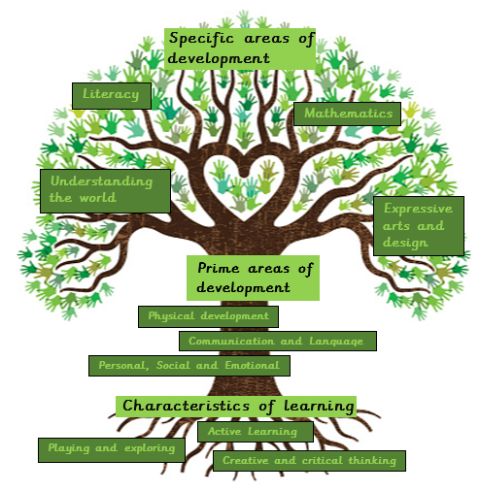

Each of these areas can then be broken down further:

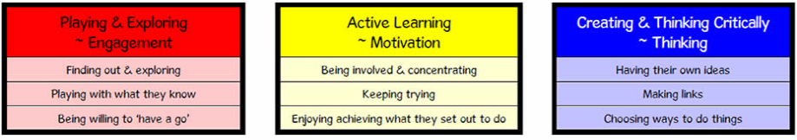

At Trailblazers Nursery, our main focus is on helping the children reach their potential within the prime areas.

Your child’s day will be organised to reflect these areas, often through a topic or theme. Children will mainly learn through practical activities as studies show that this is the most effective way for young children to learn. It may appear that they are spending most of their time ‘just playing’, but it is important to realise that their time in nursery is carefully planned. Play is essential for children’s development, building their confidence as they learn to explore, to think about problems and relate to others. Children will also have more structured times to their day which are often adult initiated and/or adult led, e.g phonics and story time.

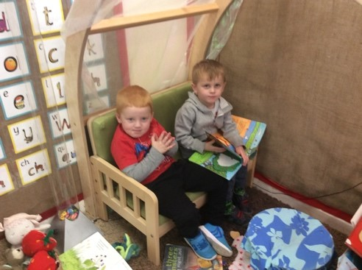

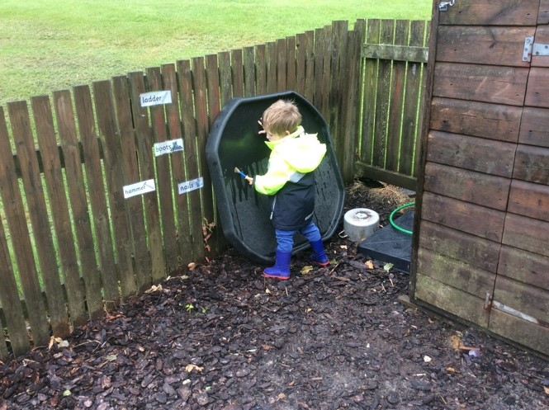

How will I know how my child is doing?
We know that a strong partnership between parents, carers and staff at nursery is crucial to children’s success.
~ As soon as your child starts nursery, we will start keeping a record of their Learning Journey, through an online programme called ‘Tapestry’. This is where we record observations of what they can do in relation to each of the seven areas of learning (listed above).
~ Your child’s Learning Journey will be available for you to access online and we would really like it if you could contribute to these by adding photos or comments about things your child does at home. This gives us a complete picture of what your child can do.
~ Before your child starts nursery (by the end of June if possible), we ask that you register for a Tapestry account through this link
~ We will continue to assess your child, through everyday nursery activities. Their progress will be assessed against the Early Years Foundation Stage Development Matters statements.
~ During the year, provided no restrictions are in place, there will be opportunities for you to come into nursery and find out how your child is getting on.
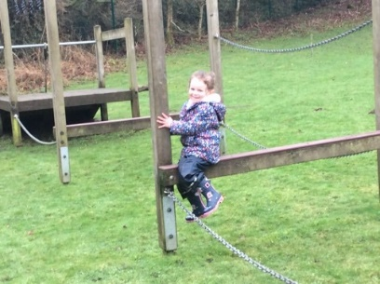

Keeping in Touch
~ On Friday we email our weekly school newsletter to you. Please provide us with an email address on the admissions form. The newsletter is also on our website at https://www.treverbyn.org.uk/web.
~ Follow Treverbyn Academy on Facebook
~ Phone us on 01726 850503
~ Email the manager on elaine.taylor@treverbyn.org.uk or hello@treverbyn.org.uk
Preparing for Nursery at Treverbyn Trailblazers
As your child settles into nursery life, they have to come to terms with leaving you and also learn about their new environment. Advance preparation can make the separation much easier. It helps if you talk about nursery in a positive manner – all the fun activities that will be on offer and all of the new friends that they will make.

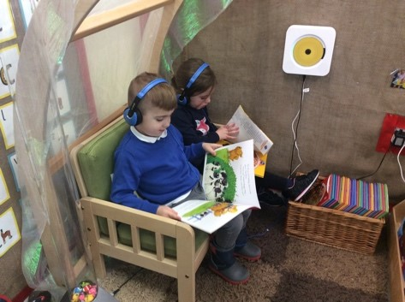
Right from the start we encourage all children to be independent, to “have a go” at putting on their coat/shoes etc. We support them with recognising their own picture as a form of self- registration and as they develop to be able to recognise their written name, in readiness for school.

Settling in
At Trailblazers Nursery we offer a free 3 hour settling in session. We welcome you to stay with your child for as long as you like, provided there are no restrictions. We ask that when you do leave, you say to your child that you are leaving now but will be back to collect them later.

If your child is unsettled when they arrive at school a member of staff will be available to look after and reassure them. We will then encourage parents to say goodbye and then to phone us to find out how they have settled. From experience, the quicker you leave, the less upsetting it is for children. A quick goodbye is less painful than extra hugs and kisses.

What does my child need for nursery?
Uniform:
At Trailblazers nursery we do not have a compulsory uniform but if you would like your child to wear the same as the school, this can be obtained from your local supermarket or Cornwall Screenprint.
To enable children to become more independent with going to the toilet, we ask parents to dress their child in trousers with an elasticated waist. In the Early Years we have a no laces policy and request that your child wears shoes with velcro straps, again for independence.

Change of Clothes: Many of the activities in the nursery involve the use of play dough, paint, etc. Although we do provide aprons there will inevitably be times when your child’s clothes get dirty. For this reason, we ask that your child is dressed in washable, easy care clothes. Please provide plenty of spare clothes including underwear and socks. Please ensure your child always come to nursery with an outdoor coat as we go outdoors most days.

Waterproofs and welly boots: Please provide a pair of wellington boots and waterproof trousers (which stay at nursery) for your child so they can access the curriculum in the outside area. Please write your child’s name clearly on these.

Water Bottle: Children learn best when they are hydrated! Please fill your child’s water bottle with cool water each morning and we will replenish as needed throughout the day.

It is very much appreciated when all nursery clothing is clearly labelled including shoes. The wearing of jewellery, other than stud earrings is not permitted.

Lunchtimes
You can purchase a lunch from Treverbyn Academy at a price of £2.30 per day and they provide a three-week rolling menu each term. You may wish to provide your child with a packed lunch. As we are a part of Healthy Under 5’s, please ensure that packed lunches are healthy and balanced and clearly labelled.

Snack Time
We provide water and milk as well as snacks each day. We have a two-week rolling snack menu which is available to view in the foyer.
Please let us know if we should be aware of any food allergies or specific dietary requirements that your child may have on their medical form.

Sun Protection
On appropriate days, please send your child to nursery with a named sun hat and wearing a factor 50 sun cream. You can send the sun cream to school for reapplication by your child before lunch time.

Head Lice
Head lice is inevitable and nothing to be embarrassed about. Wet combing your child’s conditioned hair with a nit comb will help you spot them. There are a number of effective preventions and treatments available from chemists or online. Please come and see us if you have any concerns.

Security
Our nursery and school community has a duty to safeguard and promote the welfare of children. We have a safeguarding policy and procedures in place. A general overview is contained within this prospectus. A full copy is available on request or on the school website. Sometimes we may need to share information and work in partnership with other agencies when there are concerns about a child’s welfare. We will always ensure that our concerns about our pupils are discussed with their parents/carers first, unless we have a reason to believe that it is not in the child’s best interests. If you have a concern about a child please speak to the room leader in the first instance or Mrs Elaine Taylor, the Nursery manager, our Designated Safeguarding Officer or Mr Simon Welch, Head of Treverbyn Academy, Treverbyn’s designated safeguarding lead.

Children are not allowed to leave the nursery until the appropriate adult is present.

For security reasons, if a different person is collecting your child and you have not informed the office or staff member, we will phone you to check if this is okay before letting your child go. We also operate a password system in nursery and you should only give this password to the people you have agreed can pick up your child.

If there are any changes in home circumstances which may affect how your child behaves in nursery, please let us know. Any information you give us is treated with the strictest confidence. Often we can help children more effectively if we are prepared.

First aid and medicine
All staff members are qualified first aiders and all activities are supervised. However, accidents can and do occur. We have strict procedures and staff are trained to deal with minor injuries. In serious cases, parents or emergency contacts will immediately be contacted so children can be taken to their doctor or hospital. All accidents are recorded and in the case of bumped heads, a note is sent home.

If your child is taken ill and needs to be at home, or the injury needs further medical advice, you, or someone designated by you, would be telephoned immediately. Please ensure that your contact numbers are always up to date.

Children who have had an upset stomach (vomiting and/or diarrhea) need to be absent for 48 hours after their last incident.

Medicines cannot be administered by staff unless they have been prescribed for your child by a doctor, dentist or nurse (medicines containing aspirin/paracetamol should only be given if prescribed by a doctor).
You will need to complete a form prior to this.
Children on special medication such as inhalers will have special arrangements made for them. Again, a medical form will need to be filled in.

Behaviour
To ensure that all children are happy and safe we have to insist on an acceptable standard of behaviour. Children are encouraged to follow our rules for life:
~ show good manners at all times
~ follow instructions with thought and care
~ care for everyone and everything.
Particular emphasis is placed upon the importance of sharing and developing social and emotional skills. We use positive behaviour strategies, including praise for good behaviour, as well as stickers and certificates for rewarding behaviour such as being kind, helping or trying their best.

Transition to School
Trailblazers Nursery is an integral part of Treverbyn Academy and we hope that you will take an interest in all school activities. Shortly before your child transfers to full time school, you will have an opportunity to meet the Reception Teacher and to discuss your child’s entry into the Reception Class.
We have excellent links with the Reception class at Treverbyn. If your child is going to attend Treverbyn Academy, they will have many opportunities to meet their new teacher, visit their new classroom and join in with some of the activities in the class before they transfer to the Reception Class. If your child is going to attend another school, we will do everything we can to enable a smooth transition.

Nursery check list

Wellington boots

Waterproofs (Separate coat and trousers)

Water bottle

Ruck sack with spare clothes

Remember to label all clothes with your child’s name, including wellington boots, waterproofs, bags and shoes

We hope your child will enjoy their time in the nursery. We feel confident that they will benefit from the experiences we can provide.

Contact for more information or to book a visit:
Trailblazers Nursery
Treverbyn
Stenalees
St Austell
PL26 8TL
Phone: 01726 850503
Email: elaine.taylor@treverbyn.org.uk

