Treverbyn Nursery Long Term Plan 2025-2026

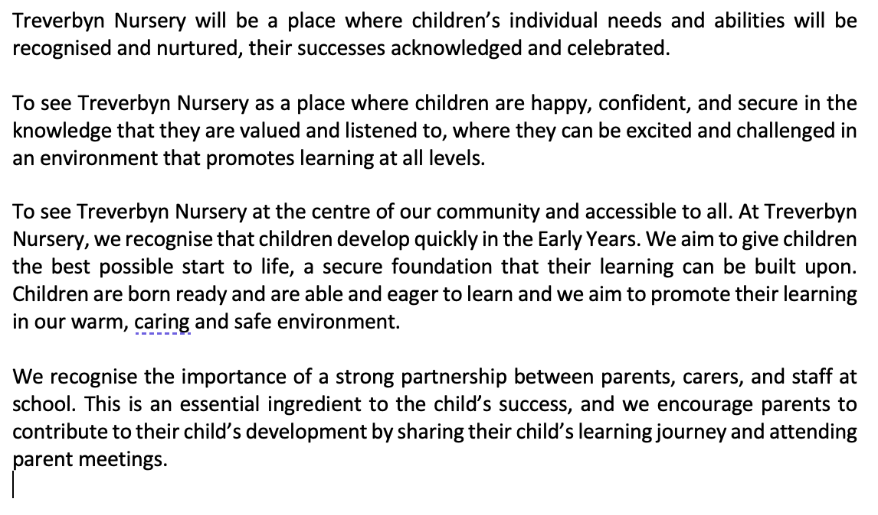

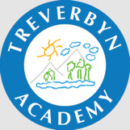 | Autumn 2025 |  | Spring 2026 |  | Summer 2026
The Big Question... | Who Am I? | What would the world look like frozen? | Why does it get dark? | Where does our food come from? | What is at the bottom of the garden? | Wildlife here and there
Forest/ sustainability theme | Me and the planet  Littering  Exploring the forest school | Why does ice melt?  Pollution  Green energy | What happens at night?  Nocturnal animals | How does our garden grow?  How seeds are spread | Why are insects important?  What do bees do? | How to look after habitats  Beach cleaning
Themes – these may be adapted to follow childrens interests. | All about me  Homes and houses  Families  The town around me / heritage  Emotions  Halloween | Frozen planet/Ice age  Arctic animals  Why do things freeze?  Fireworks  Bonfire night  Christmas | New starters  Seasonal changes  Weather changes  Chinese new year  Space  Solar system | On the farm  Plant a seed  Easter  Plant life cycles | Animal life cycles  Minibeasts  Out in nature  How does your garden grow? | Explore around the world  Habitats  Animal homes  Under the sea/coral reef
Focus Books  (damselflies) | Elmer’s Colours  Super Duper You!  Hedgehugs  Homes  Families  Room on the Broom (modified) | Owl Babies  Room on the broom (modified)  It Was a Cold Dark Night  Playtime with Pudsey  Dear Santa  Christmas Nativity  Little Bear’s Christmas | Spot goes to the Farm  Red rockets & Rainbow Jelly  That’s not my Tractor  Guess How Much I Love You  Mr Wolf’s Pancakes  Mouse Shapes  Whatever Next | Dear Zoo  Chicken Licken  Little bear  Goldilocks & the Three Bears  That’s Not My Chick | The Very Hungry Caterpillar  The Teeny, Weeny Tadpole  The Tiny Tadpole  Where is little fish?  Five tiddlly widdly tadpoles.  Ten wriggly,wiggly caterpillars. | Rainbow Fish  Spot Goes to the Beach  That’s not my Pirate  Hooray for Fidgety Fish and Friends  That’s not my Turtle  Smiley Shark  Barry the Fish with Fingers
Focus Books  (Dragonflies) | I Feel  Daisys Dragons  The zoo inside me  Joy  The same but different too  The wild  Meesha makes friends  Room on the Broom  We are going on a ghost hunt | Owl Babies  Frozen Facts  Lost and Found  The Gingerbread Man  Snow Bear  The Birth of Jesus  The Christmas story | Handa’s Surprise  Which Food will you Choose?  Mr Wolf’s Pancakes  Stickman  Guess how much I love you (story sack) | Dear Zoo  Harry & his Bucketful of Dinosaurs  Rumble in the Jungle (story sack)  Goldilocks and the Three Bears  The Billy Goats Gruff | The Very Hungry Caterpillar (story sack).  Super Worm  How much does a Ladybird Weigh?  The Enormous Turnip  Jack and The Beanstalk  Peep Inside the Garden  The Big Carrot  Mad about Minibeasts | Rainbow Fish  What the ladybird heard at the seaside  Clean Up!  The Snail and The Whale  Sharing a Shell  Smiley Shark  Our Transition Book
Key DATes | 27th Sept - British Food fortnight.  October is world blindness awareness month.  7th Oct – National poetry day.  31st Oct Diwali | 5th Nov Bonfire Night  13th Dec Christingle  25th Dec Christmas Day | Big Garden Birdwatch  27th Jan National Storytelling Week  Mon 3rd Feb – Childrens Mental Health Week  10th Feb Chinese New Year  Tues 11th Feb Shrove Tuesday Fri14th Valentines Day | February 28th International Hygge Day  3rd March World Wildlife Day  16th March British Science Week  30th March is Ramadan  17th March St Patricks Day  Sun 30th March is Mother’s Day  Sun 20th April is Easter Sunday | Wed 23rd April St George’s Day  Tue 29th April International Dance Day  Tue 20th May World Bee Day | 30 days wild Month in June – The Wildlife Trust.  Thurs 5th June World Environment Day.  Sunday 15th June Fathers Day.  Wed 18th June International Picnic Day.  Mon 23rd – 27th June  Insect Week.  Sports Day.  Sat 21st – Sun 6th July National Marine Week
Communication and Language  (damselflies) | WellComm assessments  Daily Registers  Enjoy singing, music and toys that make sounds  Listen and respond to a simple instruction | WellComm assessments  Daily Registers  Develop listening skills and focus on my own activity.  Start to say how I am feeling using words and actions | WellComm assessments  Daily Registers  Start to put two or three words together “more milk”?  I pose my questions such as names of people and objects. | WellComm assessments  Daily Registers  Join in and listen to simple stories and understand what is happening, with the help of the pictures.  Develop understanding and act on longer sentences like ‘make teddy jump’ or ‘find your coat’ | WellComm assessments  Daily Registers  Develop understand simple questions and instructions like: “Where’s your hat?” or “What’s the boy in the picture doing?” | WellComm assessments  Daily Registers  Starting to use talk with familiar adults and peers creating sentences in their play  Following instructions
Communication and Language  (dragonflies) | WellComm assessments  Daily Registers  Starting to use talk with familiar adults and peers creating sentences in their play  Following instructions  Answering questions (what, who, where, when) | WellComm Assessments  Daily Registers  Use short sentences to explain  Listen to stories and songs with interest and engagement  Using a wide range of words appropriately and in context | WellComm assessments  Daily Registers  Joining in with familiar stories and rhymes  Using different vocabulary including scientific and linked to stories  Starting to show understanding of ‘why’ questions | WellComm assessments  Daily Registers  Respond appropriately when questioned  Pose my own simple questions to find out more  Develop vocabulary  Join in and recall stories with repetition | WellComm assessments  Daily Registers  Take turns to speak in a conversation  Explore the use of conjunctions to connect ideas  Use language to explain, retell, describe | WellComm Assessments  Daily Registers  Respond to a range of question types- particularly link to ‘why’ questions  Express a point of view  Develop a wide ranging vocabulary- scientific and descriptive
PSED (damselflies  (SCARF) | SCARF:  Me and My Relationships | SCARF: Valuing Difference | SCARF: Keeping myself safe | SCARF: Rights and Responsibilities | SCARF: Being My Best | SCARF: Growing and changing  Transition into 3-4 room
PSED (dragonflies)  (SCARF) | SCARF: Me and My Relationships  Marvellous Me!  I’m Special  People who are special to me  Class rules: Behavioural expectations in the class/boundaries set | SCARF: Valuing Difference  Me and my friends  Friends and family  Including everyone  I know what it means to be respectful and to be treated with respect  Independence: putting own coat and shoes on | SCARF: Keeping myself safe  People who keep me safe  Safety indoors and outdoors  What’s safe to go into my body  Oral hygiene: teeth cleaning linked to the dental nurse Handwashing | SCARF: Rights and Responsibilities  Looking after myself  Looking after others  Looking after my environment  Healthy eating: Fruit snacks and looking after our vegetable patch | SCARF: Growing and changing  Growing and changing in nature  When I was a baby  Girls, boys and families  Transition into Reception | SCARF: Being My Best  What does my body need  I can keep trying  I can do it!  Importance of exercise  Being kind to living creatures  Taking care of animals (frogs/butterflies)
Physical Development  (damselflies) | Dance  Dough Disco  Yoga / Massage  Forest School sessions  Bikes / trikes  Large Construction  Playdough  Develop large and small motor skills.  Can you kick or throw a ball?  Learning to jump in the air with both feet off the ground |  | Dance  Dough Disco  Yoga  Forest School sessions  Bikes / trikes  Large Construction  Playdough  Tear and make marks on a variety of types of paper  Use clay, playdough with tools to promote grasping, holding and exploring different techniques and textures |  | Dance  Athletics  Massage  Forest School sessions  Bikes / trikes  Large Construction  Playdough  Using a knife and fork independently, assist with getting wellies or shoes on and off and start to attempt pulling own zips up or doing up buttons.
Physical Development  (dragonflies) | Dance  Dough Disco  Yoga / Massage  Forest School sessions  Bikes / trikes  Large Construction  Playdough / tools  Revise and use fundamental movement skills e.g. run, jump hop  Use core muscle strength to achieve good posture (start to develop handwriting posture)  Develop dominant hand for pencil control  Pour own drinks / Put Shoes on and do up own zip  Healthy Movers  Scissor skills  Core Strength / standing/ sitting / crouching  Agility and Locomotion |  | Dance  Dough Disco  Yoga  Forest School sessions  Bikes / trikes  Large Construction  Playdough / tools  Negotiate space and obstacles safely  Use different movement styles to match situations e.g. crawling through tunnels etc.  Pour own drinks / Put Shoes on and do up own zip  Use a range of tools effectively including pencils and scissors  Demonstrate strength, balance and co-ordination and experiment and use different ways of moving- bikes/ scooters. |  | Dance  Athletics  Massage  Forest School sessions  Bikes / trikes  Large Construction  Playdough / tools  Demonstrate different ways of moving  Use of large scale movements and balancing  Pour own drinks / Put Shoes on and do up own zip  Using one handed tools and equipment  Use a range of small tools effectively- drawing with accuracy  Develop the skills needed to get through the school day e.g. lining up  Developing a comfortable pencil grip  Core Strength / standing/ sitting / crouching  Balance / Stability & Body Image & Body Confidence
Literacy Reading / Phonics / Mark making  (damselflies) | Storytime / Carpet discussions  Book Lending Library  Mark making  Tracing shapes, objects, lines  Playdough  Drawing  Painting  Joining in with familiar nursery rhymes / stories and songs | Storytime / Carpet discussions  Book Lending Library  Mark making  Tracing shapes, objects, lines  Playdough  Drawing  Painting  I can listen to simple stories and understand what is happening, with the help of the pictures. | Storytime / Carpet discussions  Book Lending Library  Mark making  Tracing shapes, objects, lines  Playdough  Drawing  Painting  I have favourite books and seek them out, to share with an adult, with another child, or to look at alone | Storytime / Carpet discussions  Book Lending Library  Mark making  Tracing shapes, objects, lines  Playdough  Drawing  Painting  I can sing songs and say rhymes independently, for example, singing whilst playing.  I can repeat words and phrases from familiar stories. | Storytime / Carpet discussions  Book Lending Library  Mark making  Tracing shapes, objects, lines  Playdough  Drawing  Painting  I can ask questions about the book. I can make comments and share my own ideas | Storytime / Carpet discussions  Book Lending Library  Mark making  Tracing shapes, objects, lines  Playdough  Drawing  Painting  I can develop play around favourite stories using props / story sacks  I can use the speech sounds p, b, m, w
Literacy Reading / Phonics / Mark making  (dragonflies) | Storytime /Listening to and retelling the story  Book Lending Library  Writing my Name  Mark making  Playdough  Drawing  Painting  Look at Different range of texts – Menus, signs, Log | Storytime /Listening to and retelling the story  Book Lending Library  Writing my Name  Mark making  Playdough  Drawing  Painting  Turning pages independently in a book / reading from left to right using a finger to show where | Storytime /Listening to and retelling the story  Book Lending  Library  Writing my Name  Mark making  Playdough  Drawing  Painting  I can name objects or characters in a book and enjoy sharing my ideas | Storytime /Listening to and retelling the story  Book Lending Library  Writing My Name  Mark making  Playdough  Drawing  Painting  Use clipboards with text and instructions to follow outside, follow a recipe for mud pies | Storytime /Listening to and retelling the story  Book Lending Library  Writing My Name  Mark making  Playdough  Drawing  Painting  Change one rhyming word for another to see who can spot the changes and similarities in the word | Storytime /Listening to and retelling the story  Book Lending Library  Writing my Name  Mark making  Playdough  Drawing  Painting  Creating letters in large format outside on the ground with large chalks or using sticks or leaves to create letters
Maths  (Damselflies) | Stacking Cups / Blocks  Manipulating objects on top of / inside or alongside each other | Join in finger rhymes with numbers  Begin to react to changes of amount in a group of up to three items | Develop number sequences,  sometimes skipping numbers 1, 2, 3, _5  Climb and squeeze into smaller spaces / space awareness  Building with Duplo | Complete insert puzzles  Compare sizes of objects (bigger, smaller, higher, lower, heavier or lighter) | Following routines and anticipating what will come next | Noticing and making Patterns / the same or different
White Rose Maths  (Dragonflies) | Comparison 1 – More than Fewer than, same.  Shape, Space, Measure 1 – Explore & build with shapes & objects.  Pattern 1 – Explore repeats.  Counting 1 – Hear & say number names. | Counting 2 – Begin to order number names.  Pattern 2 – Join in with repeats.  Shape, space & measure 2 – Explore position & space.  Subitising 2 –  Show me 1,2,3 | Counting 3 – Move & label 1,2,3.  Shape, Space & measure 3 – Explore position & routes.  Counting 4 – Take & give 1,2,3. | Shape, Space & Measure 4 – Match, Talk, push & pull.  Subitising 3 – Talk about dots.  Comparison 2 – Compare & sort collections. | Pattern 4 – Lead on own repeats.  Pattern 5 – Making patterns together.  Subitising 4 – Make games and actions. | Counting 5 – Show me 5.  Pattern 6 – My own pattern.  Counting 6 – Stop at 1,2,3,4,5.
Understanding the world (Damselflies) | Explore and develop curiosity of natural materials | What natural materials can you find? | Splashing in puddles – explore rain / go outside in the rain!  Look for minibeasts / worms/ spiders  Forest school Sessions | Open ended play –  Junkbox play  Boxes, tubes, material – What can you make for  Science Week? | What’s different about me  and you? Who lives in your community?  What’s the same? | Families – yours and mine  Who are your parents? Discuss wider family
Understanding the world  (dragonflies) | Begin to make sense of their own life story  Show interest in different occupations | Talk about what they see using a wide vocabulary  Continue to develop positive attitudes about the differences between people | Use all their senses in hands on exploration of natural materials  vs  Technology / A look at technology today – robots. Machines, phones, computers | Understand the key features of the life cycle of an animal – respecting all living things  Use all their senses in hands on exploration of natural materials during Forest School sessions | Plant seeds and care for growing plants in our allotment  Understand the key features of the life cycle of a plants and animals  Use all their senses in hands on exploration of natural materials during forest school sessions | Around the world – how do they grow food?  What’s nature look like for them?
Expressive Art and Design  (damselflies) | Respond to familiar music, move and dance  Enjoy singing and making sounds / play instruments  Clapping along to the beat | Notice patterns in sounds or rhythms  Enjoy making sounds with own voice  Move whole body to music | Explore a range of painting tools  Painting with sticks  Painting with straws  Nature Brushes  Cotton wool  Painting using hands | Pretend play through small world play using animals and people / dinosaurs – using sound effects | Making prints / being creative moulding and modelling Clay or playdough / using different tools | Create pictures using different types of materials, string, tissue paper, leaves,
Expressive Art and Design  (Dragonflies) | Explore the use of colour and design  Explore tools and their uses  Use open ended resources and objects to help create ‘Small World’ stories | Invent and adapt stories through their role play and small world play  Enjoy singing songs that are familiar,  remembering the words and melody  Perform songs and stories and pitch match songs | Explore shapes through different media, in nature using sticks, leaves and other objects.  .  Drawing in greater detail, being able to show movement or emotions of a character or person drawn, | Express own  thoughts, feelings and ideas towards play, art and music – how does music make us feel?  Choose different media to create artwork – looking at other artists for inspiration.  Junkbox modelling  Material  Natural resources  Print  Sculping | Colour mixing  What happens if you mix these two colours?  What do colours look like on different materials  Explore textures when adding mud, sand or glitter to paint | Explore the use of a range of tools  Express and explain my use of materials and design to others around me  Develop pencil and tool control to create complex and detailed picture
Characteristics of Effective Learning
Playing and exploring: - Children investigate and experience things, and ‘have a go’. Children who actively participate in their own play develop a larger store of information and experiences to draw on which positively supports their learning
Active learning: - Children concentrate and keep on trying if they encounter difficulties. They are proud of their own achievements. For children to develop into self-regulating, lifelong learners they are required to take ownership, accept challenges and learn persistence.
Creating and thinking critically: - Children develop their own ideas and make links between these ideas. They think flexibly and rationally, drawing on previous experiences which help them to solve problems and reach conclusions.
Lenny Lion’s Learning Zoo:
Go For It Gorilla, Exploring Elephant, I Know Rhino, Proud Peacock, Concentrating Crocodile, Persevering Parrot, Choosing Chimp, Creative Chameleon & Slinky Linky Snake

