[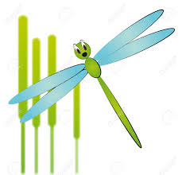](http://www.google.co.uk/imgres?imgurl=http://previews.123rf.com/images/willypd/willypd1105/willypd110500014/9476586-illustration-of-cartoon-dragonfly-with-reeds-Stock-Vector-bug.jpg&imgrefurl=http://www.123rf.com/photo_9476586_illustration-of-cartoon-dragonfly-with-reeds.html&h=1251&w=1300&tbnid=6TOXCtIJR6HqkM:&zoom=1&q=Cartoon+damselflies&docid=4OsDeaMA23qa6M&hl=en&ei=Y5ddVce2ILSS7AaqpoK4Cw&tbm=isch&ved=0CEEQMygXMBc)Damselflies 02.02.16

This term we are looking at the Chinese New Year which is the year of the monkey. If you have anything to do with this topic and would be happy to share with us we would appreciate this.

The children have started making Chinese lanterns & been painting with noodles.



Welcome back to Damselflies after the Christmas break we all hope that you had a lovely time with your children and wish you all a happy new year.  
We would like to welcome all of our new children to Damselflies and hope that they will enjoy their time with us



If your child requires a two year check, home visit or a “time to talk” meeting then a member of staff will contact you in due course to arrange this. Please check your child’s drawer for any info.

This half term we are also encouraging the children to become more independent in their scissor control. To help your child with this at home you could encourage them to pick small items up using tweezers if you are not brave enough to let them loose on scissors at home!!

 

If you are not able to access Tapestry you can still fill out "wow" cards to add to your child's learning journey.  If you need any support with tapestry, please ask Lorraine or Cathy.

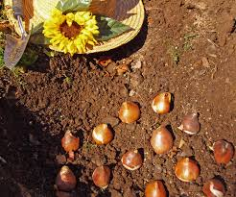

We are hoping to do bulb planting, exploring the outside garden area as well as looking at all the changes that will happen in the environment over the coming months.

In Damselflies we always have some sort of messy play so please provide your child with spare 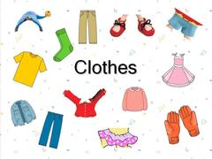

Our theme is Winter and we will be looking at animals that are around in the winter.

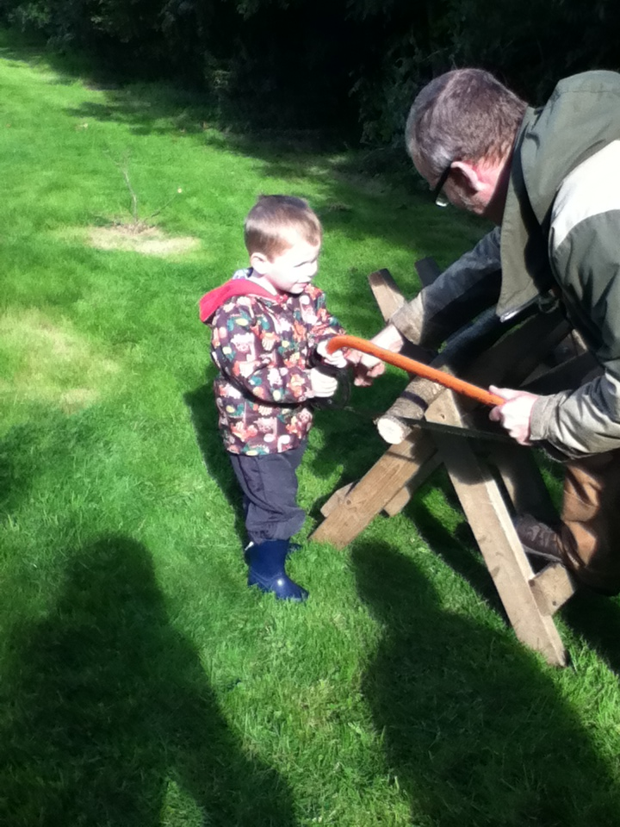

Please provide your child with the appropriate clothing e.g. warm coat,wellies & plenty of nappies and wipes if required.