[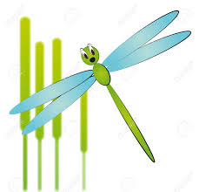](http://www.google.co.uk/imgres?imgurl=http://previews.123rf.com/images/willypd/willypd1105/willypd110500014/9476586-illustration-of-cartoon-dragonfly-with-reeds-Stock-Vector-bug.jpg&imgrefurl=http://www.123rf.com/photo_9476586_illustration-of-cartoon-dragonfly-with-reeds.html&h=1251&w=1300&tbnid=6TOXCtIJR6HqkM:&zoom=1&q=Cartoon+damselflies&docid=4OsDeaMA23qa6M&hl=en&ei=Y5ddVce2ILSS7AaqpoK4Cw&tbm=isch&ved=0CEEQMygXMBc)Damselflies 14th Dec 2015

We will be starting the term looking at the Chinese New Year which will be the year of the monkey. If you have anything to do with this topic and would be happy to share with us we would appreciate this.



Next term the children will be involved in lots of lovely activities so that we can step into Spring. If there is something you think your child is particularly interested in please inform us so that we can incorporate it into the planning.



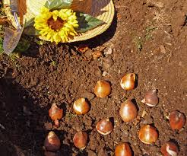

We are hoping to do bulb planting, exploring the outside garden area as well as looking at all the changes that will happen in the environment over the coming months.

If your child requires a two year check, home visit or a “time to talk” meeting then a member of staff will contact you in due course to arrange this. Please check your child’s drawer for any info.

The staff in Damselflies would like to wish you all a very Merry Christmas and a wonderful New Year.  
MERRY CHRISTMAS XXX

We will be losing some of our older children into the Dragonflies room. We all wish them well and hope that their transition is a nice, smooth and an enjoyable experience and that they continue to flourish in Dragonflies.

Here in Damselflies we will be welcoming some new children which is very exciting.

In Damselflies we always have some sort of messy play so please provide your child with spare 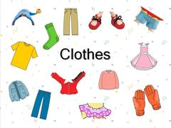

Our theme is Winter and we will be looking at animals that are around in the winter.

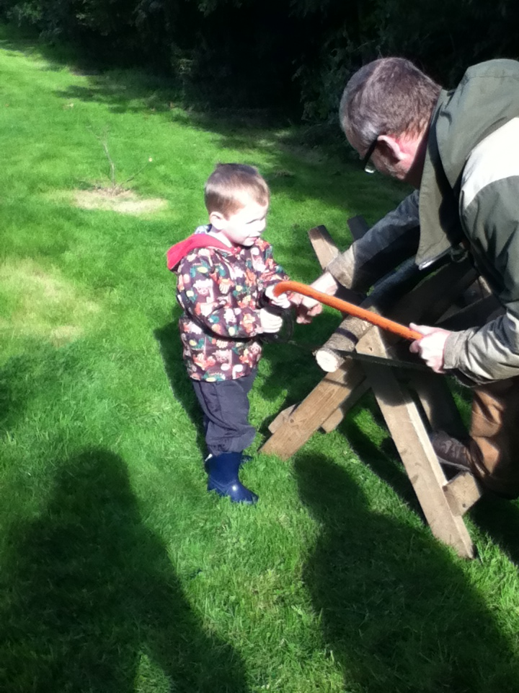

Please provide your child with the appropriate clothing & plenty of nappies and wipes if required.