[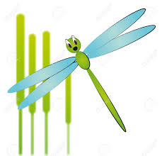](http://www.google.co.uk/imgres?imgurl=http://previews.123rf.com/images/willypd/willypd1105/willypd110500014/9476586-illustration-of-cartoon-dragonfly-with-reeds-Stock-Vector-bug.jpg&imgrefurl=http://www.123rf.com/photo_9476586_illustration-of-cartoon-dragonfly-with-reeds.html&h=1251&w=1300&tbnid=6TOXCtIJR6HqkM:&zoom=1&q=Cartoon+damselflies&docid=4OsDeaMA23qa6M&hl=en&ei=Y5ddVce2ILSS7AaqpoK4Cw&tbm=isch&ved=0CEEQMygXMBc)Damselflies 11th Nov 2015

The children have been making bonfire pictures & firework prints for our display board. They had the opportunity to see real sparklers and we talked about the importance of fire safety, with special visits from fire brigade & the police.

C:\Program Files\Microsoft Office\MEDIA\CAGCAT10\j0251301.wmf

Welcome back to Damselflies after the half term. We hope you all had a lovely week off with your children. If there is something you think your child is particularly interested in please inform us so that we can incorporate it into the planning.



C:\Program Files\Microsoft Office\MEDIA\CAGCAT10\j0183290.wmfWe are starting to think about Christmas and over the coming weeks the children will be writing letters to Santa, designing our Christmas tree plus other exciting activities, which will definitely involve a lot of glitter!!

If your child requires a two year check, home visit or a “time to talk” meeting then a member of staff will contact you in due course to arrange this. Please check your child’s drawer for any info.

C:\Program Files\Microsoft Office\MEDIA\CAGCAT10\j0299587.wmf

Our theme is winter and we will be looking at animals that are around in the winter.

In Damselflies we always have some sort of messy play so please provide your child with spare 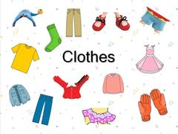

*C:\Program Files\Microsoft Office\MEDIA\CAGCAT10\j0149407.wmf*

*We have started to practice our songs for the Christingle service, which will be held in Treverbyn Church Fri 11th* [*dec@1.30*](mailto:dec@1.30) *(more details to follow).*

*Children’s Xmas party will be Fri 18th dec @ 10.30 and the nursery closes at 1.30pm, please look out for your separate letter.*

Our theme is Winter and we will be looking at animals that are around in the winter.

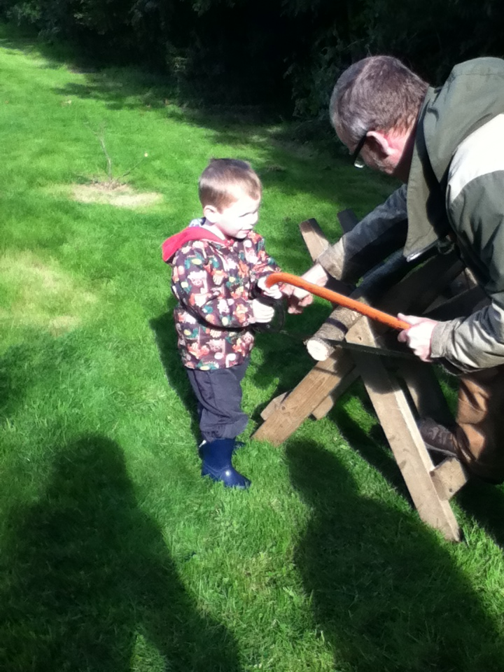

Please provide your child with the appropriate clothing & plenty of nappies and wipes if required.