Year 4 Summer Term Homework
To be handed in before Wednesday 19th July
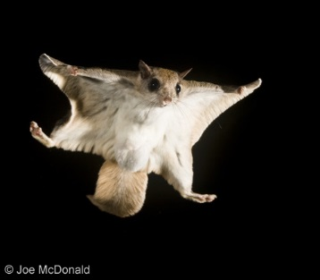
Design a new creature which you believe could live on our planet. Explain why it has the features you have chosen for it
(eg. night vision, webbed feet).

OR
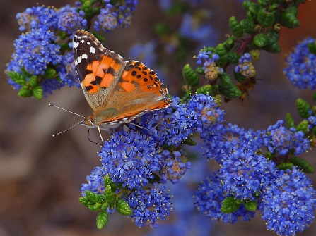
Collect information about the plants/grasses or the wildlife found in your garden or a patch of land near you (perhaps focus on a 1 metre squared area). Present your information any way you choose.

